GloV

Definition
# Source: AI Source: Provided by: [Data Path: Persons Table -> ID Column: 1, Name_En Column: Motasem Essam] -> From: [ChatGPT] on [12/10/2025]
GloVe is a word embedding technique that represents words as dense vectors by analyzing global word co-occurrence statistics from a large corpus. It was developed by Stanford University and is widely used in natural language processing (NLP) tasks.

Key Idea
# Source: AI Source: Provided by: [Data Path: Persons Table -> ID Column: 1, Name_En Column: Motasem Essam] -> From: [ChatGPT] on [12/10/2025]
Unlike Word2Vec, which relies on local context, GloVe captures both local and global statistical information about word co-occurrences in a corpus. Words that appear in similar contexts across the corpus have vectors that are close in the embedding space.

How It Works
# Source: AI Source: Provided by: [Data Path: Persons Table -> ID Column: 1, Name_En Column: Motasem Essam] -> From: [ChatGPT] on [12/10/2025]
- Build a co-occurrence matrix of words in the corpus:
  - Each entry (X_{ij}) represents how often word (j) appears in the context of word (i).
- Learn word vectors by factorizing the co-occurrence matrix to preserve word relationships.
- The resulting vectors capture semantic meaning: similar words have similar vector representations.

Example
# Source: AI Source: Provided by: [Data Path: Persons Table -> ID Column: 1, Name_En Column: Motasem Essam] -> From: [ChatGPT] on [12/10/2025]
Consider words: "king", "queen", "man", "woman"
GloVe embeddings (simplified 3D example):
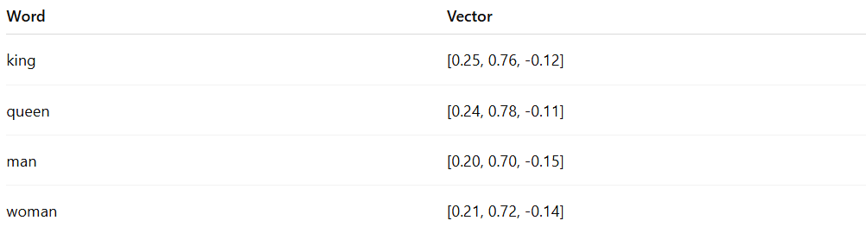
Word | Vector
king | [0.25, 0.76, -0.12]
queen | [0.24, 0.78, -0.11]
man | [0.20, 0.70, -0.15]
woman | [0.21, 0.72, -0.14]
- Semantic operations work similarly:
"king" - "man" + "woman" ≈ "queen"

Applications
# Source: AI Source: Provided by: [Data Path: Persons Table -> ID Column: 1, Name_En Column: Motasem Essam] -> From: [ChatGPT] on [12/10/2025]
- Text classification and sentiment analysis
- Named entity recognition (NER)
- Semantic similarity and clustering
- Machine translation and recommendation systems

Advantages
# Source: AI Source: Provided by: [Data Path: Persons Table -> ID Column: 1, Name_En Column: Motasem Essam] -> From: [ChatGPT] on [12/10/2025]
- Captures global corpus statistics and semantic relationships
- Produces dense, low-dimensional vectors
- Can perform word analogy operations

Disadvantages
# Source: AI Source: Provided by: [Data Path: Persons Table -> ID Column: 1, Name_En Column: Motasem Essam] -> From: [ChatGPT] on [12/10/2025]
- Static embeddings: same vector for a word regardless of context
- Requires large corpora for accurate vectors
- Cannot handle out-of-vocabulary words without retraining or additional techniques

